- The surge in gilt yields has continued this week. We identify three interrelated causes. There's a heavy global influence, led by the US. Markets have become more hawkish about the near-term monetary policy outlook. And the rise in long-dated gilts has been larger, reflecting rising global term premia, high issuance, and the Bank of England's quantitative tightening programme.
- We expect the BoE to cut Bank Rate more quickly than markets anticipate. This suggests there's scope for yields to fall back at the front end of the curve. But with higher global term premia and concerns about fiscal sustainability likely to linger, yields at the long-end could remain elevated.
It's been a turbulent week in financial markets, with UK government bond yields rising sharply. Despite many commentators directly linking the recent repricing of UK assets to the country's gloomy fiscal prospects, our conclusion is that global influences have been the main factor behind market movements.
The 10-year gilt yield has risen 60bps since the start of December, with 25bps of that increase occurring since the turn of the year. This week's sell-off came in response to US job opening data that supported a slower pace of rate cuts in 2025. As has regularly been the case in recent months, US developments had a large impact on UK asset prices. Markets pared back bets on Bank of England rate cuts over the next couple of years and there was a rise in the front-end of the UK yield curve.
In concert with higher yields on short-dated gilts, the 10-year gilt yield jumped 22bps between the start of this week and Thursday's close. The spread of gilts over German bunds has risen over recent months, but the spread between gilts and US Treasuries has been more stable. This is indicative of both market confidence in the European Central Bank's ability to deliver swift rate cuts and that higher gilt yields at the front end of the curve are not primarily being driven by UK-specific factors (Chart 1).
Chart 1: The spread of UK gilts over US Treasuries has been fairly stable in recent months
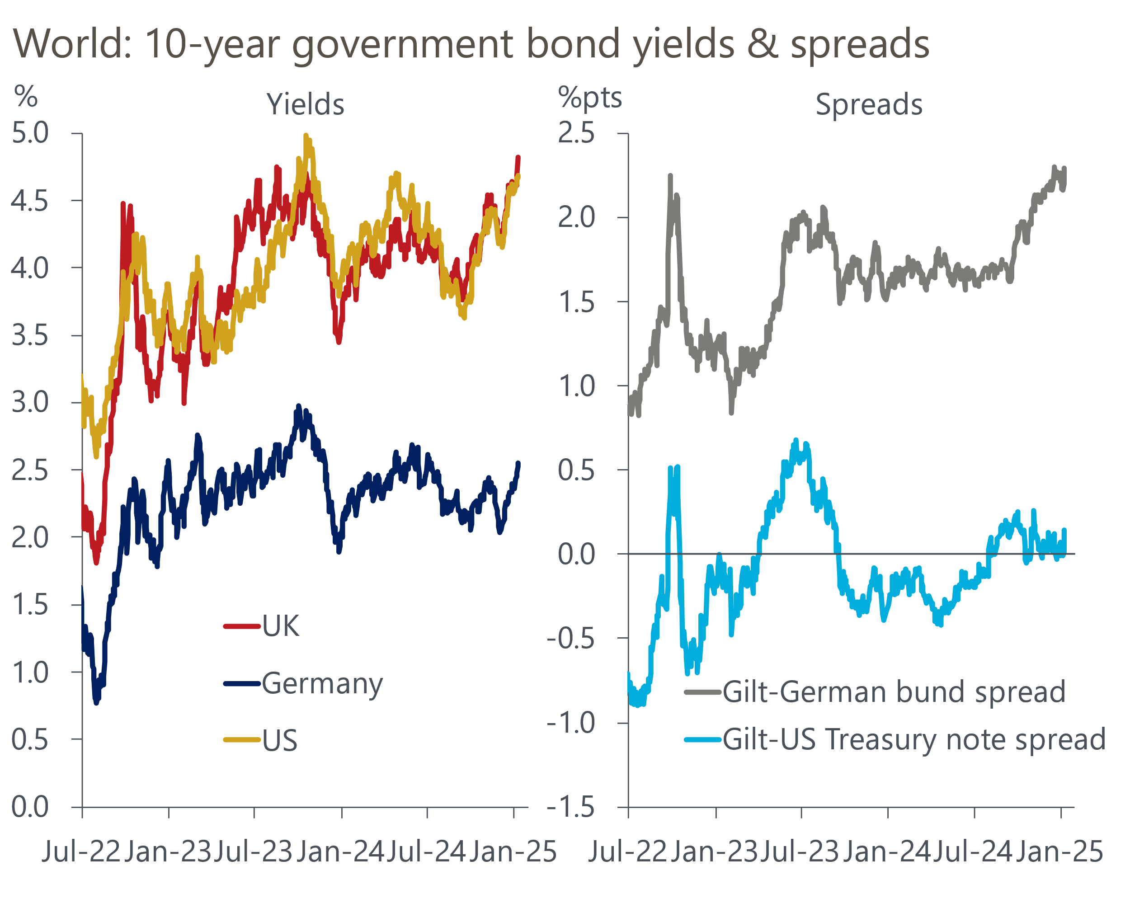
Source: Haver Analytics

Upward pressure has been greatest at the longer end of the curve, with the 30-year yield rising 27bps since the turn of the year to reach its highest level since 1998. There's been an increase in term premia across the world, as markets price-in growing risks around the future paths of key economic variables. However, we also think there is a domestic element at play too. Market participants have to absorb a lot of extra gilt issuance as a result of much higher borrowing plans announced in the October 2024 Budget, with a lot of that extra supply coming at the medium- and long-end. These conditions have likely been exacerbated by the BoE's quantitative tightening programme.
Higher borrowing costs threaten to cause problems for the government. The Office for Budget Responsibility will lock its financial assumptions in early-February ahead of the publication of its next forecast on March 26. If the recent increases in gilt yields and market expectations for Bank Rate are sustained, we calculate it would wipe out the Chancellor's headroom against her fiscal rules. Not only would this intensify concerns about the sustainability of the public finances, but a substantial tightening of financial conditions would also weigh on economic activity.
We believe that market pricing is out of kilter with the monetary policy outlook. Following the repricing earlier this week, markets expect the Monetary Policy Committee to deliver just two 25bps rate cuts by mid-2026 (Chart 2).
Chart 2: Market pricing has risen sharply since the MPC's December meeting
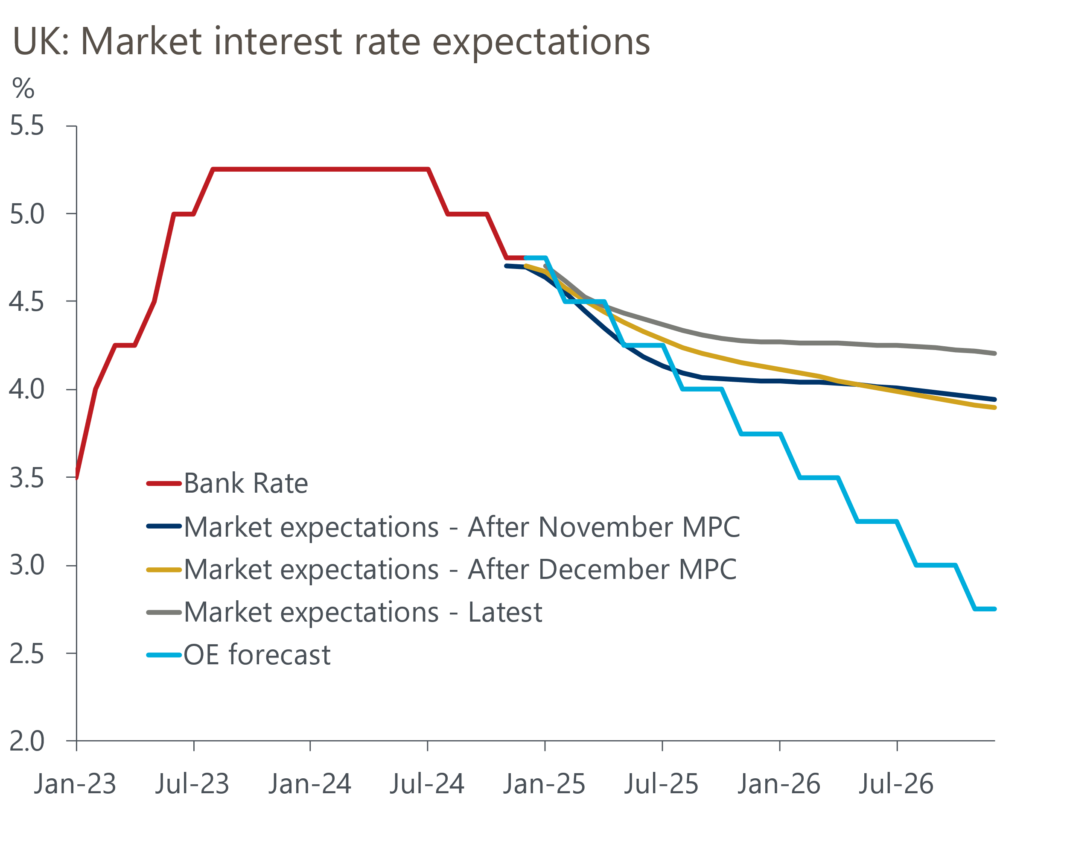
Sources: Oxford Economics, Haver Analytics
This week's BoE's Decision Maker Panel for December suggested that inflation expectations are bottoming out as survey respondents reported that year-ahead price expectations rose for the second consecutive month. But the minutes of December's MPC meeting said that the majority of committee members are now placing a greater emphasis on the implications of the recent weakness in activity and employment in their decision-making. So as part of our global economic forecast update that will be published later today, we have stuck with our projection for 100bps of rate cuts in 2025. Our conviction in this call was bolstered on Thursday by BoE Deputy Governor Sarah Breeden, who remarked in a speech at the University of Edinburgh that she continued to support the case for Bank Rate to come down gradually in the coming months.
As we've argued, the increase in yields is mainly a global story. However, if domestic fiscal concerns introduce a risk premium on UK assets, then the MPC might need to keep Bank Rate higher in order to dampen the inflationary impact of a weaker pound. But we see this as a risk, rather than being our baseline assumption.
Consistent with our view that the MPC will cut rates more quickly than markets are expecting, we think there's scope for gilt yields at the front-end of the curve to fall back in the near-term. However, with elevated term premia likely to be a feature across the world through 2025, concerns about UK fiscal sustainability unlikely to fade, and the slow burn of high issuance continuing to impact, we expect the yield on long-dated gilts to remain stubbornly high for now.

The week ahead
We estimate that CPI inflation rose to 2.7% in December. Base effects are likely to be the main cause of the pickup in inflation. A weak reading for core goods prices at the end of 2023 should mean the category made a slightly higher contribution to headline inflation in December. In addition, weekly data from the Department of Environment and Climate Change suggests petrol prices climbed 1.3% between November and December, having dropped by 5.1% over the same period in 2023. However, the upward pressure from these sources is likely to have been mitigated by softer outturns in the services and food categories.
Next week will also see the release of GDP data for November. October's outturn underwhelmed, but there were several erratic movements at the sectoral level – particularly in the mining, construction, and consumer-facing services sectors – that weighed on growth. There's a good chance that weakness in some of these sectors unwound in November, so we think the month saw GDP grow by 0.2% m/m.
Retail sales rose modestly in November after two successive declines. With a large proportion of annual sales coming in November and December, this makes seasonally adjusting the data difficult. This was likely exacerbated by Black Friday falling into the December reporting period in 2024, rather than November. This means a wide range of outcomes is possible for December's release. We have pencilled in a small 0.1% m/m uptick in monthly sales.
Table 1: Week ahead calendar
Date | Events | Period | Measure | Unit | Previous | Forecast
Jan 15 | CPI inflation | Dec | m/m | % | 0.1 | 0.5
Jan 15 | CPI inflation | Dec | y/y | % | 2.6 | 2.7
Jan 15 | RPI inflation | Dec | m/m | % | 0.1 | 0.9
Jan 15 | RPI inflation | Dec | y/y | % | 3.6 | 4.0
Jan 15 | Producer input prices | Dec | m/m | % | 0.1 | 0.2
Jan 15 | Producer input prices | Dec | y/y | % | -1.8 | -1.2
Jan 15 | Producer output prices | Dec | m/m | % | 0.3 | 0.1
Jan 15 | Producer output prices | Dec | y/y | % | -0.6 | 0.0
Jan 16 | GDP | Nov | m/m | % | -0.1 | 0.2
Jan 16 | GDP | Nov | 3m/3m | % | 0.0 | 0.0
Jan 16 | Index of services | Nov | m/m | % | 0.0 | 0.2
Jan 16 | Index of services | Nov | 3m/3m | % | 0.0 | 0.1
Jan 16 | Manufacturing output | Nov | m/m | % | -0.6 | 0.5
Jan 16 | Manufacturing output | Nov | y/y | % | -0.5 | -0.4
Jan 16 | Industrial production | Nov | m/m | % | -0.6 | 0.3
Jan 16 | Industrial production | Nov | y/y | % | -1.2 | -1.1
Jan 16 | Construction output | Nov | m/m | % | -0.5 | 0.5
Jan 16 | Construction output | Nov | y/y | % | -0.7 | 0.1
Jan 16 | UK trade | Nov | Trade balance | £bn | -3.7 | -3.5
Jan 16 | UK trade | Nov | Visible balance | £bn | -19.0 | -17.9
Jan 17 | Retail sales inc fuel | Dec | m/m | % | 0.2 | 0.1
Jan 17 | Retail sales inc fuel | Dec | y/y | % | 0.5 | 4.6
Source: Oxford Economics

Key forecasts
Table 2: UK forecast overview
(Annual percentage changes unless specified)
 | 2022 | 2023 | 2024 | 2025 | 2026 | 2027
GDP | 4.8 | 0.4 | 0.8 | 1.1 | 1.7 | 1.8
Private consumption | 7.3 | 0.4 | 1.0 | 1.4 | 1.5 | 1.6
Fixed investment | 5.1 | 0.3 | 1.1 | 0.3 | 3.3 | 2.6
Government consumption | 0.6 | 1.0 | 2.1 | 2.6 | 1.6 | 1.6
Exports of goods and services | 12.6 | -3.2 | -2.2 | 0.0 | 1.6 | 1.5
Imports of goods and services | 13.0 | -4.5 | 1.3 | 1.6 | 1.8 | 1.5
Industrial Production | -6.4 | -0.9 | -1.5 | 0.0 | 1.2 | 1.2
Consumer prices | 9.1 | 7.3 | 2.6 | 2.9 | 2.4 | 2.0
Unemployment rate (%) | 3.8 | 4.1 | 4.3 | 4.4 | 4.3 | 4.2
Current a/c balance (% of GDP) | -2.2 | -2.2 | -2.6 | -2.8 | -2.7 | -2.6
Government balance (% of GDP) | 4.1 | 5.2 | 4.5 | 3.3 | 2.6 | 1.8
Central bank policy rate (%, EOP) | 3.50 | 5.25 | 4.75 | 3.75 | 3.00 | 2.50
10yr govt. bond yield (%, EOP) | 3.67 | 3.54 | 4.57 | 4.22 | 3.86 | 3.44
Exchange rate (US$ per £, EOP) | 1.20 | 1.27 | 1.25 | 1.26 | 1.27 | 1.28
Exchange rate (euro per £, EOP) | 1.13 | 1.15 | 1.21 | 1.19 | 1.19 | 1.19
Source: Oxford Economics
Table 3: Quarterly forecasts for the UK
 | 2024 |  |  |  | 2025
 | Q1 | Q2 | Q3 | Q4 | Q1 | Q2 | Q3 | Q4
GDP (% year) | 0.3 | 0.7 | 0.9 | 1.2 | 0.9 | 0.9 | 1.2 | 1.6
CPI inflation (% year) | 3.5 | 2.1 | 2.1 | 2.5 | 2.7 | 2.8 | 3.3 | 3.0
Bank Rate (%, EOP) | 5.25 | 5.25 | 5.00 | 4.75 | 4.50 | 4.25 | 4.00 | 3.75
10yr gilt yield (%, EOP) | 3.95 | 4.17 | 4.00 | 4.57 | 4.40 | 4.36 | 4.29 | 4.22
US$ per £ (EOP) | 1.26 | 1.26 | 1.34 | 1.25 | 1.24 | 1.24 | 1.25 | 1.26
Euro per £ (EOP) | 1.17 | 1.18 | 1.20 | 1.21 | 1.20 | 1.20 | 1.19 | 1.19
Source: Oxford Economics

Latest Country Economic Forecast:
December 10, 2024

Recent publications

Data Insights
PMI confirms soft end to 2024
Surprise fall in mortgage approvals in November
Manufacturing PMI ended 2024 on a disappointing note
Downwards growth revision confirms Q3 slowdown
Changes in market pricing more important than borrowing data

Research Briefings
Mortgage arrears to remain high as debt interest costs linger
December hold, but MPC still on track to cut in February
MPC preview – No urgency to switch up the tempo
Why Bank Rate will fall further than markets think
Key themes 2025 – Worrying debt dynamics shift into focus

Contacts

Oxford Economics' UK team
- Andrew Goodwin - Chief UK Economist - agoodwin@oxfordeconomics.com
- Edward Allenby - UK Economist - eallenby@oxfordeconomics.com

